Homework 4

Asiqul Hoque

1/5/15

Section 16: Lesson 3 Comparison Operators

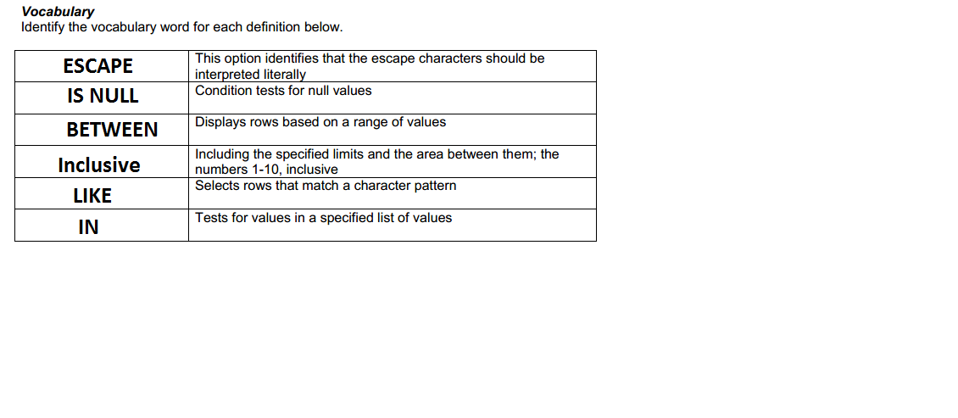

1. SELECT first_name, last_name, salary

FROM f_staffs

WHERE salary BETWEEN 5.00 AND 10.00;

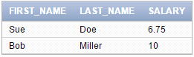

2. SELECT loc_type, comments

FROM D_Venues

WHERE loc_type = 'Private Home';

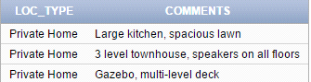

3. SELECT first_name, last_name

FROM f_staffs

WHERE salary >= 20.00 AND salary <= 60.00;



4. Create a list of all the DJs on Demand CD titles that have “a” as the second letter in the

title.

SELECT title

FROM D_CDS

WHERE title LIKE '_a%';

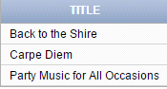

5. SELECT first_name,last_name

FROM d_partners

WHERE auth_expense_amt IS NULL;

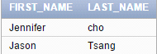

6. SELECT last_name AS "Possible Candidates"

FROM employees

WHERE last_name LIKE '%s';

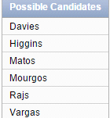

7. C

8. SELECT title,artist,type_code

FROM d_songs

WHERE Type_code IN (77,12,1);

